**State Bank of India**

SBI is an Indian multinational public sector banking and financial statutory body headquartered in Mumbai, Mharashtra. The [Government of India](https://en.wikipedia.org/wiki/Government_of_India) took control of the Imperial Bank of India on 1st july 1955, with [Reserve Bank of India](https://en.wikipedia.org/wiki/Reserve_Bank_of_India) (India's central bank) taking a 60% stake, renaming it the State Bank of India. As of march 2019, SBI employed over 2.5 lak employees with total assets being approx. ₹50.80914 trillion.

**Market Share :-**

It is the largest bank in India with a 23% market share in assets, besides a share of one-fourth of the total loan and deposits market.

**Portfolio distribution :-**

As per corporate shareholdings filed for March 31, 2020, SBI publicly holds 95 stocks with a net worth of over Rs. 91,070.8 Cr. From the above graphs it is clear that as of 30th April’2020, Government of India holds the largest portfolio of SBI and more than 70% portfolios are associated with very low levels of risk.

**Historical price chart for SBI :-**

As listed on NSE and BSE, the 52-week high and the 52-week low is Rs.373.70 and Rs.149.55 per share respectively. From the 1Y historical price chart of SBI share below, it is clear that coronavirus has impacted the price to fall from an average height of Rs.338/share to as low as Rs.170/share within a span of 3 months i.e. march’20 to june’20.

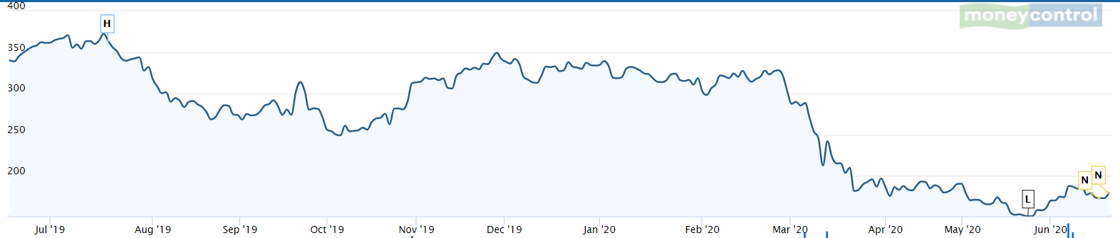

*Historical price trends of SBI, Source : Money Control*

**Profitability :-**

The bank’s primary source of income is the interest income, which has grown at an increasing rate as can be seen from the graph below. Apart from this, SBI posted a net profit of Rs 838 crore in the March quarter against a loss of Rs 7,718 crore in the year earlier.

However it can be seen that the net profit has more or less remained unchanged until the annual year of 2019.

**KEY FINANCIAL METRICS:-**

**Return on Assets** : The bank has recorded consistent growth in ROA. Below is the comparison of SBI’s ROA with 3 other public sectors banks.

**OTHER KEY RATIOS :-**

|  |  |  |
| --- | --- | --- |
| **earnings per share** | **EPS(trailing)** | 0.813594798 |
| **price to earnings ratio** | **P/E** | 214.9718759 |
| **price to book ratio** | **P/B** | 0.79532536 |
| **debt to equity ratio** | **D/E** | 106.514708 |
| **return on equity** | **ROE** | 0.10696939 |
| **price to sales ratio** | **P/S** | 1.18 |
| **current ratio** | **CR** | 18.37049677 |
| **dividend yield** | **div yield** | 0 |

SBI's overall Capital Adequacy Ratio (CAR), as on March 31, 2020, stood at 13.06 per cent, with CET (common equity tier)-I capital at 9.77 per cent.

**COVID-19 Impact on Public Sector Banks :-**

The public sector banks had started recovering in the third quarter after returning to profitability 2019-20 and  were looking at posting better numbers for the fourth quarter. However, the [coronavirus](https://bfsi.economictimes.indiatimes.com/tag/coronavirus) outbreak, which was first reported on December 31, 2019, when the third fiscal ended, has dashed those hopes. Instead, banks are staring at losses as the crisis has worsened and the ten-day lockdown is set to engulf all sectors.

SBI being a major catalyst in provision of loans to various sectors like MSME’S, Hospitality, Airlines has been directly impacted by this global pandemic.

**COVID-19 Measures taken by SBI :-**

* [State Bank of India](https://www.business-standard.com/topic/state-bank-of-india)(SBI), the country’s largest lender, kept its 22,000-strong branch network and nearly 60,000 automated teller machines (ATMs) functional during the lockdown.
* It also went online to reach out to its customers, with top officials directly connected with customers to explain a range of products that the government introduced as part of its stimulus packages.

**Overview :-**

SBI is a few points above its 52-week low and is expected to recover further. Analysts say it is profitable to invest in SBI share costing Rs.185-Rs.190 to have a upper hand on the risk-reward outcome of SBIN. The 39 reports from 15 analysts offering long term price targets for State Bank of India have an average target of 304.43. SBI has shown decades-long improvement in financial terms and with some fiscal measures, it is expected to overcome the coronavirus loophole in years to come.

**Sources :**

1. MoneyControl
2. Investopedia
3. Wikipedia

-by Nimisha Sharaff